**ROYAL OAK PRIMARY SCHOOL FUN RUN – WEEK 2 UPDATE**

Thanks to your generosity we have now raised over **$5,300** which is fantastic ……. and this means the teachers are going to get slimed!! Please see below the timetable for each day 😊

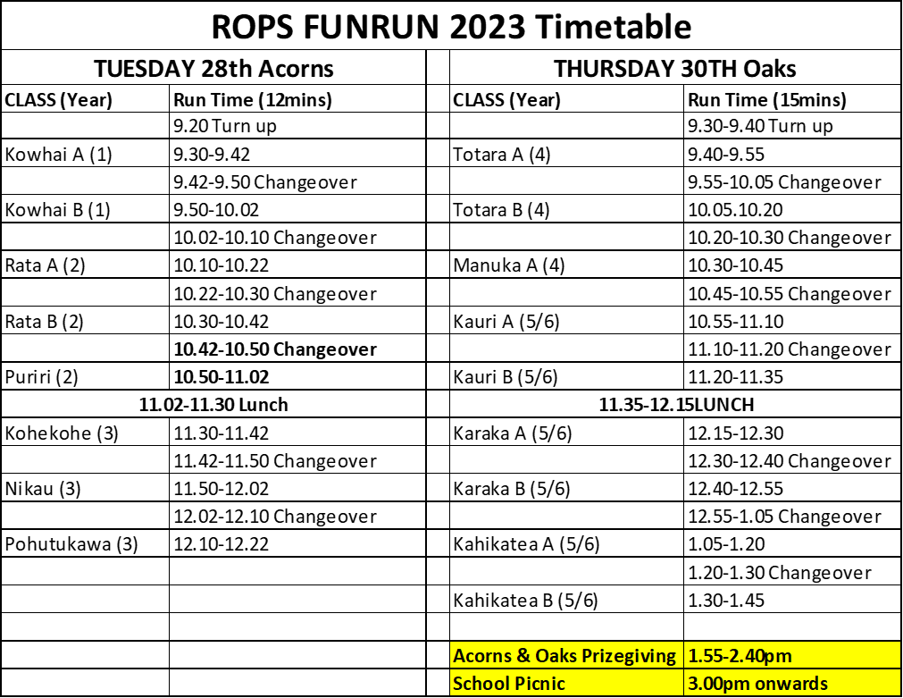

**THE LATEST CLASS RANKINGS**



**Please share this link with as many friends and whanau as possible** 😊

